Spiral 1,035

Spiral was a collective of African American artists that briefly formed in New York City between 1963 and 1966. Romare Bearden and Norman Lewis were the main founders and leaders of the group. The first meeting convened in Bearden’s studio, with Charles Alston, Felrath Hines, Lewis, Richard Mayhew, William Prichard, Hale Woodruff, and James Yeargens in attendance. Later, they were joined by Emma Amos, Calvin Douglass, Perry Ferguson, Reginald Gammon, Alvin Hollingsworth, William Majors, Earle Miller, and Merton Simpson. Prompted by a sense of momentum and urgency from the Civil Rights movement and the imminent March on Washington that summer, the group gathered to discuss the role of art in the struggle for equal rights. The artists were also eager to discuss racism and their exclusion from New York’s art world. Older artists such as Woodruff and Alston were influenced by the tenets of the New Negro movement—a movement in the early twentieth century that encouraged African American artists to use art to achieve racial progress by refashioning the image of the Negro as self-assertive and urbane. Under their influence the question of a “black art” and “black aesthetic,” which put the artists’ racial identity at the center of the debate, remained central to the Spiral group.

The group’s symbol, the Archimedian spiral, embodied its aims: “from a starting point, it moves outward embracing all directions, yet constantly upward.” The expansive and elevating movement of the spiral implies racial uplift and progress. Like the spiral, the artists came together around a central set of concerns and then expanded outward. However, the group promoted artistic autonomy and entertained divergent philosophical positions. There was no single aesthetic that dominated the group, and the artists drew from different sources, such as Abstract Expressionism, European Modernism, and African themes and motifs. The lack of consensus was a strength and weakness for the group, both providing a forum for debate and eventually precipitating its dissolution. The group was divided over the appropriate aesthetic strategy for Modern African American artists—abstraction or representation—and whether there was such a thing as a “Negro Image”—a unique quality to African American art—that distinguished it, whether via a racial essence or a shared racial experience, from other forms of art making.

Spiral’s main founding members, Bearden and Lewis, exemplified the group’s aesthetic differences. Lewis, the first elected president of Spiral, pursued abstraction as a means to express a universal human self. He was frustrated by the seeming futility of the socially-conscious Social Realist style of the WPA. Abstract Expressionism provided him artistic autonomy and an escape from the burden of producing a “Negro Image”. Though Lewis insisted that his frequent use of black paint was a formal decision, the titles of his works from the 1960s recall the racial politics of the decade: American Totem (1960) and Klu Klux Klan (1963). Despite his desire for artistic autonomy, Lewis maintained a concern for the social role of art and its relationship to the public. Throughout his career, he struggled to reconcile his artistic ambitions with his experience as a labour organiser and his commitment to the Civil Rights Movement.

Similarly to Lewis, Bearden abandoned American Scene painting for figural abstraction early in his career before fully embracing nonobjective, gestural abstraction. To attempt a reconciliation of Spiral’s aesthetic disagreements, Bearden proposed that the artists collectively make a collage that merged abstraction and figuration. Though he failed to galvanise the group around a common project, the proposal prompted the move to collage, the main medium for the rest of his career. His collage works merge modern aesthetics—photomontage, shallow pictorial space, and abstracted forms—with figurative and narrative imagery that depicts the daily lives and social rituals of African Americans. Bearden’s interest in affirming the rich cultural traditions of African Americans references more directly contemporary political conditions than Lewis’ abstract compositions. Each of these directions, however, were viable strategies pursued by Spiral artists negotiating their political convictions and personal artistic goals.

In the autumn of 1963, Spiral artists rented and renovated a gallery and meeting space at 147 Christopher Street in Greenwich Village. The gallery was financially supported by member contributions, and hosted Spiral’s only group exhibition, First Group Showing: Works in Black and White in 1965. Despite a lack of philosophical consensus, the exhibition achieved a visual unity by restricting the artists’ palettes to black and white. Stylistically, the color scheme related to current modes of abstract and gestural painting in New York and, symbolically, to the on-going social conflict between blacks and whites in the Civil Rights movement. The proceeds of the exhibition were meant to help fund Civil Rights organizations.

Though Spiral existed for only a few years, it anticipated and informed future African American artist collectives and activists who sought to address the exclusion of African American artists from mainstream art world. Bearden and Lewis were key figures in the protest against the Harlem on My Mind exhibition at the Metropolitan Museum of Art in 1968-69. Gammon participated in the protests and helped found the Black Emergency Cultural Coalition (1969) to address the exclusion of black artists from the museum. Spiral also impacted the individual careers of its members. Despite debates turning into conflicts, Amos, the only woman in the group, recalled how the conversations and relationships with older, more established artists nurtured her intellectual development and connected her to other African American artists and their work. Though the members of Spiral did not resolve the enduring question as to whether or how art could contribute to a social movement like the Civil Rights movement, the question has continued to promote serious debate and consideration today.

References and further readings:

Bearden, R. and H. Henderson. (1993) A History of African-American Artists: From 1792 to the Present, New York: Pantheon.

Farrington, L. (2007) ‘Emma Amos: Art as Legacy,’ Women’s Art Journal, 28 (1): 3-11.

Jefferson, G. E. (2005) ‘Bridging Generations: Reminiscing with Reggie [Gammon],” International Review of African American Art , 20(3): 38-45.

Martin, C. J. (2011) ‘From the Center: The Spiral Group, 1963-1966,’ NKA: Journal of Contemporary African Art, 29: 86-98.

Patton, S. (1998) African-American Art. Oxford: Oxford University Press.

Siegal, J. (2011) ‘Why Spiral?’ NKA: Journal of Contemporary African Art, 29: 78-84.

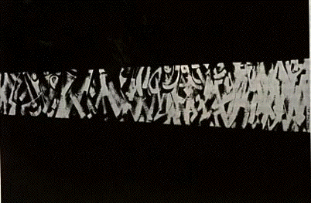

Norman Lewis, Processional, 1964, 38 1/4 x 57 3/4 in., Collection Ouida B. Lewis, New York. Work included in Spiral’s group exhibition First Group Showing (reproduced in Bearden & Henderson)

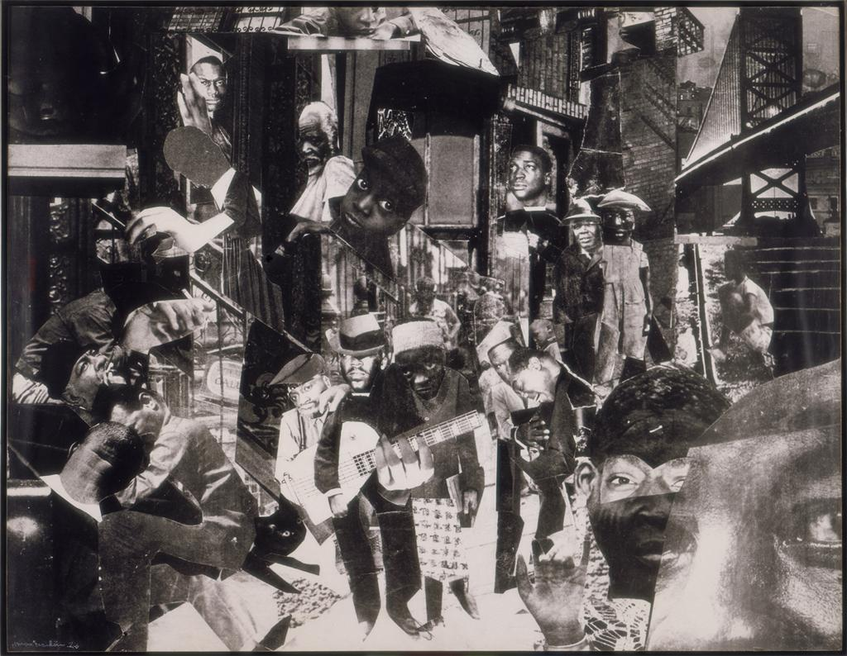

Romare Bearde, The Street, 1964, 31 x 40 in. photomontage
Art © Estate of Romare Bearden / Licensed by VAGA, New York, NY. This work of art is protected by copyright and/or related rights and may not be reproduced in any manner, except as permitted under the ARTstor Digital Library Terms and Conditions of Use, without the prior express written authorization of VAGA, 350 Fifth Avenue, Suite 2820, New York, NY 10118. Tel.: 212-736-6666; Fax: 212-736-6767; Email: info@vagarights.com.

Contact information: Diedra Harris-Kelley, Co-Director, Romare Bearden Foundation, 2090 Adam Clayton Powell Jr. Blvd., Suite 202, New York, NY 10027; Phone: 212-665-9550; Fax: 212-665-9555; Email: diedra.harriskelley@beardenfoundation.org

